**Munzer Mahmood Project Analysis**

**PROJECT PROPOSAL FORM**

**ALTERNATIVE PROJECT IDEA**

**Investigation of MediApp:**

I undertook several investigations to see how I could improve the current system to the best of its ability.

**Observation of GP staff Daniel O’Blake:**

Daniel is an employee working at one of the many GPs for nearly 3 years. His main job is to take details from patients to give them LogIn details to being a registered patient, as well as helping out with any queries a patient might have. The observation shows how he goes through a regular day.

Date of observation: 13/10/19

Place of Observation: Mr Daniel’s GP chamber

1. What does the end user do?

* Greets the patient and spends some time chatting about what Mr Mahmood’s(patient) illness and what might make his day to day life easier.
* Asks all required details for Mr Mahood to become a registered patient. i.e bank details, home address, full name, DOB etc and records them onto an Excel file.
* Gives the patient a username and password for the account after all validation of required details.
* Ask the patient what he’s suffering from and does some check ups and runs a few general tests such as blood tests and urine tests and keeps the samples for further analysis
* And then hands out a prescription of the medicines the patient might need and gives a schedule on when to take these medicines.

1. What does the end user record and where?

* Records everything on an Excel File
* Illness patient is suffering from
* The diet the patient maintains
* Any other condition patient may suffer from that might affect him taking medication
* Patient information includes
* Patient FIrst name and Surname
* Patient Contact number
* Patient Bank Details
* Patient DOB
* Patient Address
* Patient National Insurance Number

**Interview with Daniel O’Blake ( nurse of GP)**

To help understand the end-user a bit better, I interviewed Mr Blake to see how he currently performs the tasks, as well as understanding the main difficulties he faces with the current system.

Date of Interview: 14/10/19

Interviewee: Daniel O’Blake

1. **What does the user interface look like and what do users have to do?**

“ The user interface in the beginning is usually a login screen which requires the Patients or users to put in their username and password as there are different patients with different illnesses who need to have different account. A newly registered user would have to put in or set the days and times and quantities for the medicines they have been told to when they were in for their bookings with the GP.This enables the program to carry out its operation of reminding patients to take their medication”

1. **How do you feel about using your current system?**

“It had worked well for the three years we’ve been using it, but there have been a few complaints about it. Now that you have mentioned all the new possible features, I feel like it is getting a little bit outdated.”

1. **So at what point did you realise that an improvement was needed and how would you like to improve the process?**

“ When patients came in complaining how the app fails to do what its meant for and the hardships they face to come to they GP as they’re all suffering from illnesses. II would like for it to have more features to make it more convenient for users.And also take in account that a database for the whole year calendar must be added to stop the main operation of the program is reminding the user's from take medication from failing”

**Summary of Investigation:**

From this investigation, we can understand how the current system will benefit from having a news system running the application. From complaints of the Patients, it is apparent that customers will be open to using one and adding any extra features that are absent in existing application will be more appealing to users.

The features that the end user will have will include an easy interface, an option to put in what medical conditions they suffer from, GPS feature to locate local pharmacies for emergency, new automated message alerts from GP, a tick box feature for the app to keep track of amount being taken etc

1. What I found out
2. What measures will be taken to re-engineer how the day-to-day task will be conducted
3. Identify end user needs, e.g.

Medication Reminder and Shipment Program

**Background Information Of MediApp:**

I am the creator and owner of MediApp, which is mainly a medication reminder for patients who are usually of old age, suffer from memory loss or live by themselves. I thought of this app when I found out my uncle with Parkinson’s who had to be in constant medication received an app to use from the NHS. The app itself wasn’t convenient and user friendly enough for my uncle in reminding him to taking medicine and to use. It also had a lack of other functions which I thought would be very useful in giving more options of different usage to users and make everyday life for such patients easier. I have discussed all the new functions further into my analysis. Work has been going on with this project of mine for almost 2 years now and I hope to finish it by the end of this year.

**Problems with the current system:**

The current program my uncle is using happens to lack a feature which if put in, could aid users/patients immensely.

“The app majority of the time, fails to remind me to take my medication.”

Complaints from my uncle and seemed to be quite a common problem within his friends who suffer from illness as well. I looked into the matter and the problem seemed to be due to the absence of a database for the yearly calendar from which the program could collect data to carry on its operations of keeping track of the days and times set by the user/patient.

Enabling the users of the program, a feature to input their medical condition would’ve helped too in terms of the fact that over set periods of time, patients can have a change in their medical condition and respectively edit their scheduling and timetabling data and also change the name of their medicines as well as different conditions require different medicines and timing to take them. A patient could also suffer from multiple conditions. This clearly wasn’t taken into an agenda during the programming of this current app.

As I’ve mentioned earlier that these apps are like personal assistants who make life easier for patients who are usually of old age, suffer from memory loss or live by themselves and cannot take care of themselves and have no one to take care of them. Therefore, the need of automated messages is highly required, as most patients either have a hard time walking to the pharmacy to get more medicines or even lose track or forget how much medicine is left and that they’ve run out or need to be taking medication.

A tick box feature popping up after being reminded by the app to take medication would’ve let the program know how many medicines are being taken and how much is left leading to an end of the month message to the GP for shipment of more medicines to the patient’s address using the data from the registered patient details.

**Constraints and Limitations:**

Before creating the program, there are a number of constraints that may lower the quality of the program and disrupt the progress:

* **Time Constraints**: The project will be restricted to a certain time frame which could allow the absence of some extra features – i.e. an options for Patients who use Private Clinics or the GPS feature and the automated message feature which occurs by keeping track of amount of medicine left
* **Data Protection**: As there is personal data being stored onto the system, security measures must be put in place to ensure sensitive information is stored correctly. However due to the limitations of expert programming skills, such measures to be kept can be unlikely
* **Users ICT Skill Level:** The application will need to be simplistic in navigation between input screens and daily operations to use for all users, meaning the program interface shouldn’t be too complex and show all options to access every feature in a well understood comprehensive way.

|  |  |
| --- | --- |
| Objective | Performance criteria |
| 1. Create a secure storage area for patient personal details such as bank details as transactions will be made through their preferred devices whether phones or laptops using a database and secured with passwords or users with access. | This must be secured so that only the end user can access this data. |
| 1. Users will be able to set remainders for taking medication | 2)&3) For this, I need to create a database for the date and time, and the dosage for the medicine as different patients may have different dosage for the same medicine. Then a tab checking the medicines remaining. The program will use the data from the database knowing which day and time the patient has set for it to remind them to take the medication. The tab will work by(as mentioned in objective 3) the tick box feature to let the patients know how much medication is left. This will done by an algorithm linking to the tick box function, when every time the tick box is clicked, the amount of dosage put in by the patients will be deducted through arithmetic operations. |
| 1. They will have a tick box feature to let the program keep track of whether they’ve taken the medication or not and also keep track of dosage |
| 1. Patients will have the feature for booking appointments with the GP | Patients can go to ‘Booking Appointments’ tab in the program, where available dates will be shown for them to book. Once clicked, a textbox will appear displaying “Booking Confirmed. Would you like to receive an email” The email feature will be carried out by a number functions and conditional statments like this ( code snippet from application’s source code)  Public Class frmReceiveEmail  Public sEmail As String = ""    Private Function OkayToSave() As Boolean  Dim bRetVal As Boolean = False  ErrorProvider1.Clear()    If txtEmail.Text = "" Then  ErrorProvider1.SetError(txtEmail, "Please Enter Email")  txtEmail.Focus()  Else  bRetVal = True  End If  Return bRetVal  End Function    Private Sub btnOK_Click(sender As Object, e As EventArgs) Handles btnOK.Click    If OkayToSave() Then    sEmail = txtEmail.Text  Me.Close()  End If  End Sub  Private Sub frmReceiveEmail_Load(sender As Object, e As EventArgs) Handles MyBase.Load    txtEmail.Focus()  End Sub  End Class |
| 1. They will have a textbox to input their medical condition which will then be stored into the database | Medical Condition, once input, will be saved off in the database. Patients can also add more if they want to make a change like having a new condition. There will be an ‘add on’ feature |
| 1. A google maps feature to track nearby pharmacies | A very efficient google maps feature will be in the main form after log in is done. To help people find the nearby hospitals or pharmacies. |

Data Flow Diagram For New proposed System

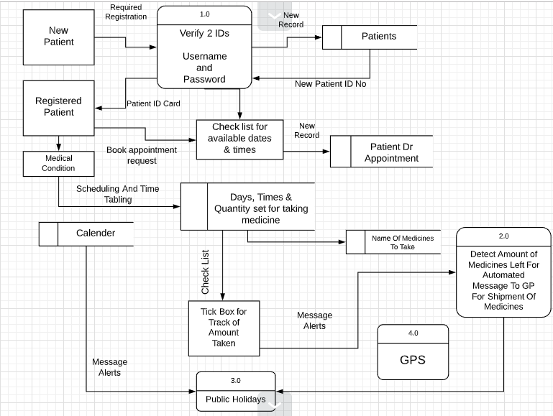

Data Flow Diagram for current System

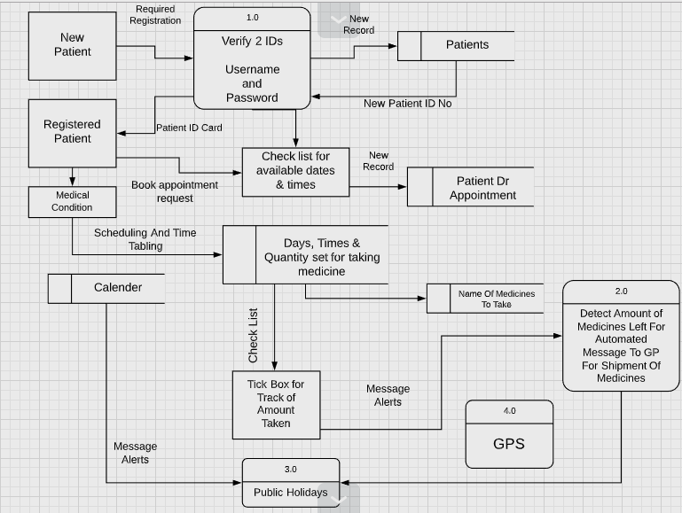

**Modelling the current system:**

**IPSO Analysis Chart**

|  |  |  |
| --- | --- | --- |
| **IPSO** | **Information** | **Evidence** |
| Input | Customer Information:   * First name - Email * Surname - Address * Phone Number - Medical History * DOB | Observation notes/Interview |
| Input | Medicine Scheduling Information:   * Date and Time -Medical Condition * Dosage -GP Information | Observation notes |
| Process | * Remind patient to take medicine | Observation notes |
| Store | -Patient Details  -Medicine Scheduling Details | Observation notes |
| Output | - Medication reminders  -Instruction of based output from user | Observation notes/Interview |

**Modelling The New System:**

**IPSO Analysis Chart**

|  |  |  |
| --- | --- | --- |
| **IPSO** | **Information** | **Evidence** |
| Input | Customer Information:   * First name - Email * Surname - Address * Phone Number - Medical History * DOB -Bank Details | Observation notes/Interview |
| Input | Medicine Scheduling Information:   * Date and Time -Medical Condition * Dosage -GP Information * Prescription Details | Observation notes |
| Process | * Remind patient to take medicine * Shipment of medicine by use of data from patient details * Find Location using GPS * Automated messages * Banking Transactions * Calculating the cost of orders | Observation notes |
| Store | -Patient Details  -Medicine Scheduling Details  -Prescription Details | Observation notes |
| Output | - Medication reminders  -Instruction of based output from user  -Automatic Orders | Observation notes/Interview |

These diagrams allow the description of the system to be seen clearly, breaking it into subsections and allowing the evidence of the investigation to be practically shown. This allows the current process to be depicted, and how these processes can be changed for the updated/new system

**Entity Relationship Diagram**

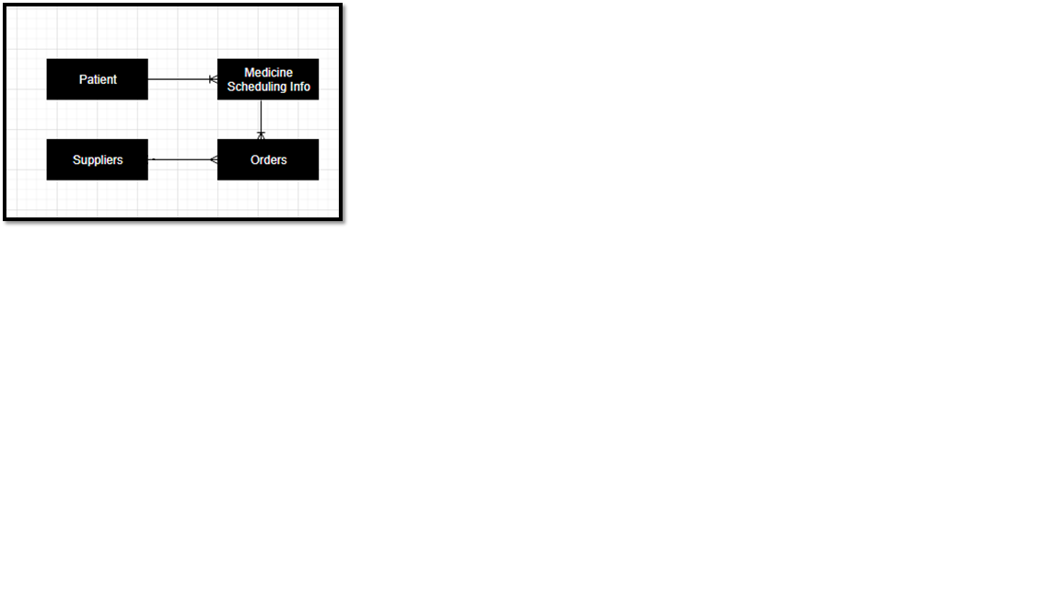

|  |  |  |  |
| --- | --- | --- | --- |
| Data Item | Data type | Validation | Sample Data |
| Patient ID | Integer | Length of 6, Integer | 112439 |
| Patient FirstName | String | NotNull | Jason |
| Patient Surname | String | NotNull | Aberfield |
| Patient Username | String | Length of 8, String | J.Aberfield |
| Patient Password | String | >8 characters | Jason1232 |
| Patient Address | String | NotNull | 39 Romford Road,London |
| Patient Postcode | String | NotNull | E7 9HL |
| Patient Email | String | NotNul, Must have ‘@’ | j.aberfield@gmail.com |
| Patient Banking Details | String | NotNull | Sort Code: 40-05-66  Account Number: 2335 7777 9856 4312  CVV: 487 |
| Patient Phone No | String | = 11 digits | 07508824572 |
| Patient DOB | Date And Time | DD/MM/YY | 23/08/1997 |
| Patient Medical Condition | String | NotNull | Schizophrenia |

**Data Dictionary**

|  |  |
| --- | --- |
| Table Name | Patients |
| Primary Key | Patient ID |
| Foreign Key | N/A |

**Data Volumes**

|  |  |
| --- | --- |
| **Data Object** | **Volume of Data** |
| **New Patients** | **Average of 320 per year** |
| **Registered Patients** | **350** |
| **Number of Booking Appointments** | **Average of 270 per month** |
| **Number of medicines ordered** | **Average of 680 per month** |
| **Supplier order Generated** | **Average of 675 per month** |

**Context Diagram**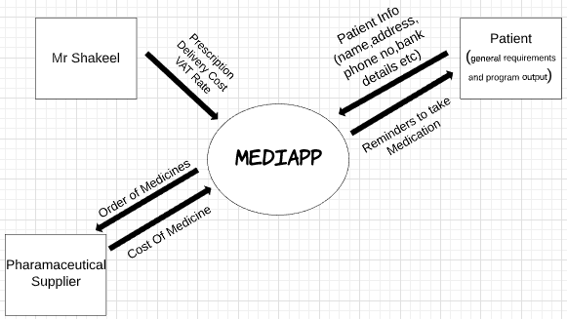

**Flow Chart Diagrams for the new system**

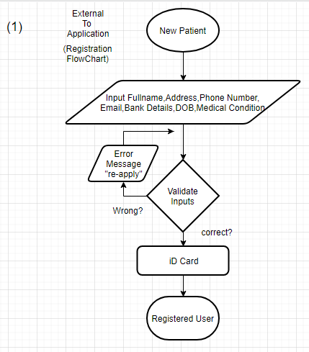

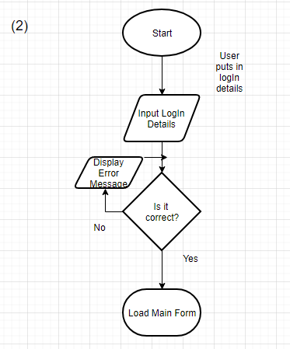

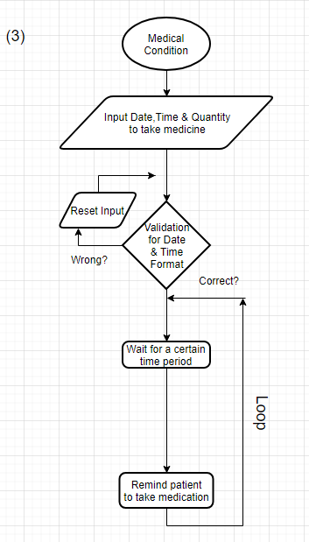**(3)**